Miniatures in Modern Design

Selections from The Eloise Kruger Gallery of Miniatures

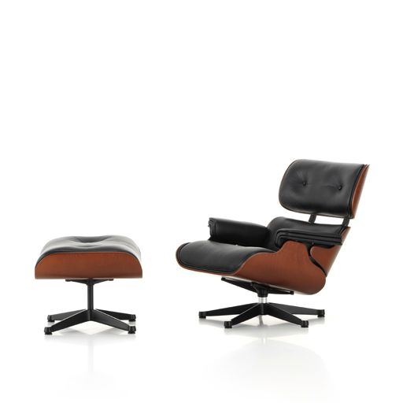



**University of Nebraska – Lincoln**

**School of Global Integrative Studies**

**Eloise Kruger Gallery of Miniatures**

831 Oldfather Hall  
Lincoln, NE 68588-0368

# Welcome

Welcome to Miniatures in Modern Design. The Eloise Kruger Gallery of Miniatures is delighted to share this collection with you. These works reflect not only the artistry of miniature craftsmanship, but also the creativity and vision of the designers whose full-scale pieces shaped the history of modern design.  
  
We are especially grateful to David and Terrie Irvin, Al Stone, the Eloise Kruger Charitable Trust, and other private donors, whose generosity makes this exhibition possible. Their gifts ensure that the gallery continues to serve as a place of learning, curiosity, and appreciation for the art of miniatures.

We invite you to look closely, notice the details, and enjoy the remarkable world of design—at a scale that brings wonder to the eye and imagination to the mind.

In addition to donating many of the objects on view, David and Terrie Irvin also provided the gallery’s lighted display cases, which allow these miniatures to be enjoyed in their finest detail.

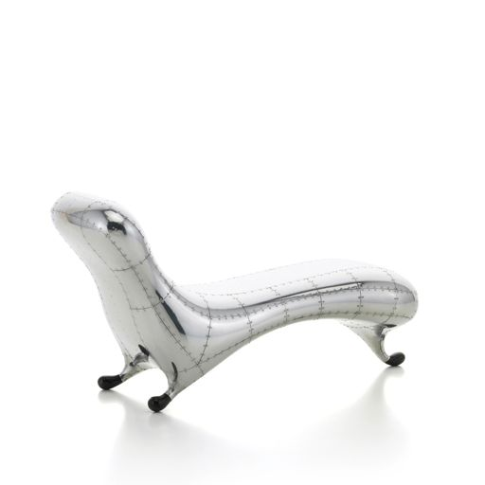

# Curatorial Statement

This exhibition highlights a unique collection of 1:6 scale miniatures donated to The Eloise Kruger Gallery of Miniatures by generous supporters, including David and Terrie Irvin, Al Stone, and the Eloise Kruger Charitable Trust.  
  
Crafted with meticulous attention to detail, most of these miniatures were produced by the Vitra Design Museum, renowned for its recreations of iconic modern furniture and design. Each piece embodies the innovation, craftsmanship, and playful spirit of twentieth-century design, distilled into collectible form.  
  
Together, the collection offers not only a celebration of design history, but also a testament to the generosity of donors who continue to expand the gallery’s holdings for study, inspiration, and enjoyment.

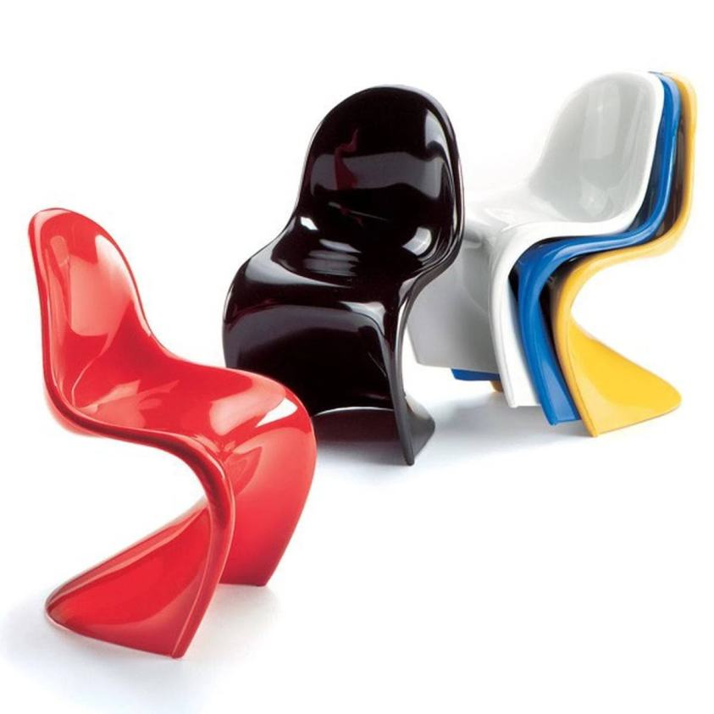

# Works in the Exhibition

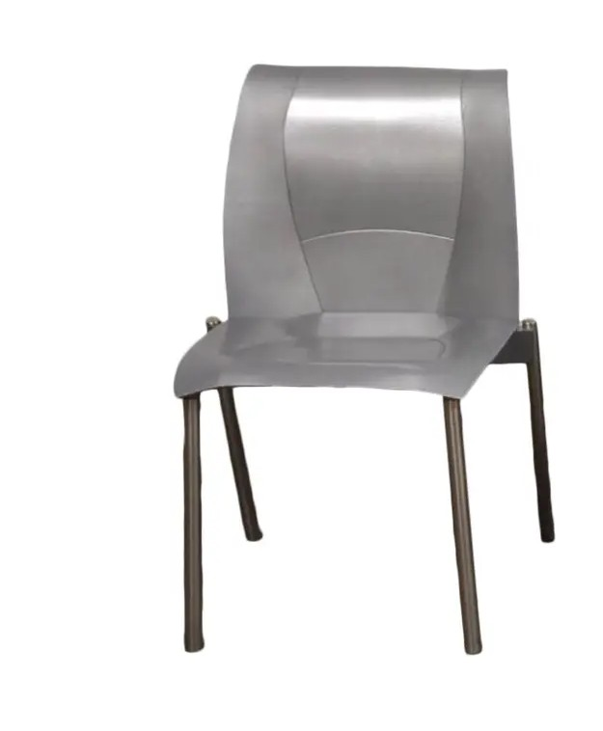

## 2001.2; FOG Armchair, 1999

Designer: Frank Gehry  
Maker: Knoll Design Studio  
Material: stainless steel  
Donor: Knoll, Inc.

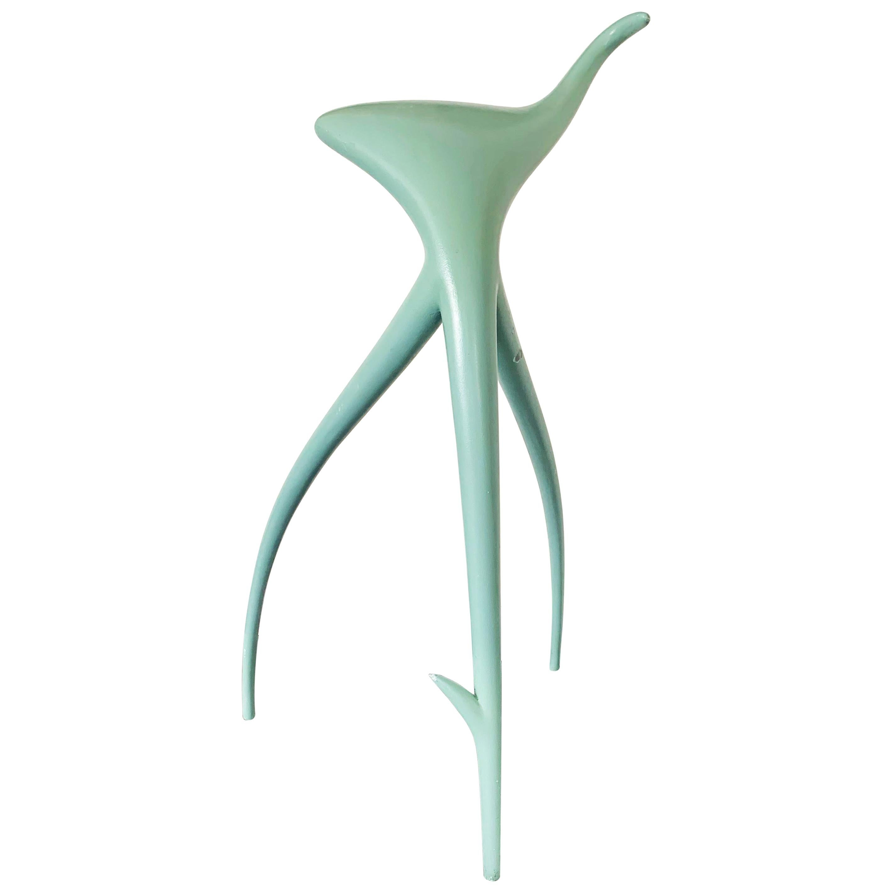

## 2005.1; W.W. Stool, 1990

Designer: Philippe Starck  
Maker: Vitra Design Museum  
Material: metal, varnish  
Donor: Eloise Kruger Charitable Trust

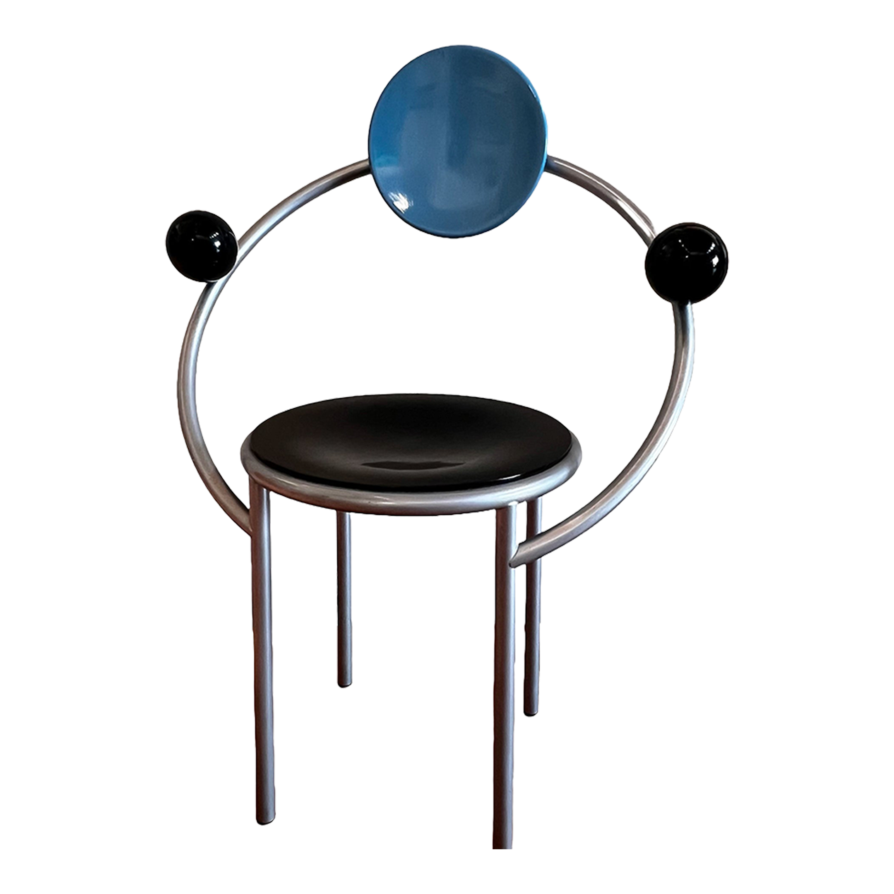

## 2005.2; First, 1983

Designer: Michele De Lucchi  
Maker: Vitra Design Museum  
Material: metal, wood, paint  
Donor: Eloise Kruger Charitable Trust

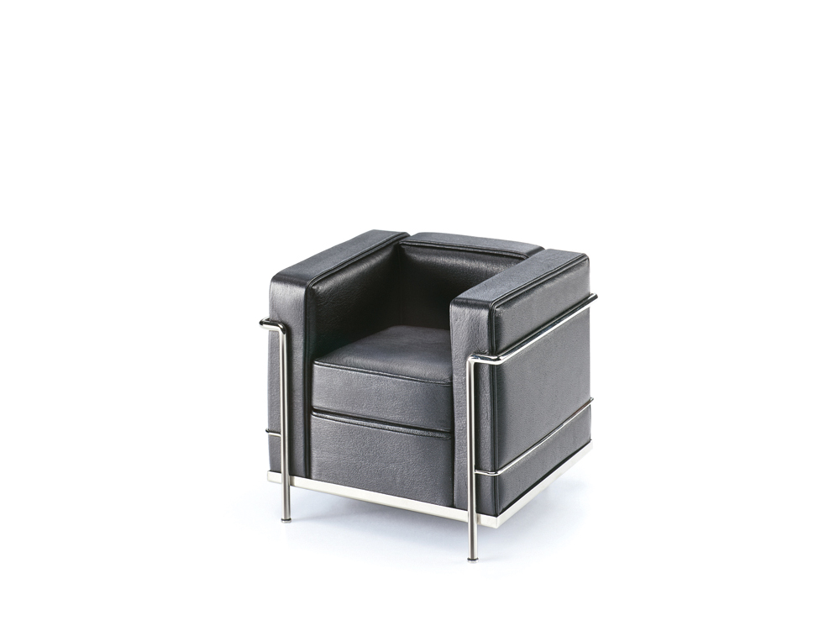

## 2008.1; Grand Confort

Designer: Le Corbusier, Pierre Jeanneret & Charlotte Perriand  
Maker: Vitra Design Museum  
Material: nickel-plated tubular steel, leather  
Donor: Eloise Kruger Charitable Trust

## A brown leather chair on a white background2008.2; MR 90 Barcelona, 1929

Designer: Ludwig Mies van der Rohe  
Maker: Vitra Design Museum  
Material: steel, leather  
Donor: Eloise Kruger Charitable Trust



## 2010.4 a, b; No. 670 Lounge Chair & No. 671 Ottoman

Designer: Charles & Ray Eames  
Maker: Vitra Design Museum  
Material: bent plywood, cast aluminum, leather  
Donor: David & Terrie Irvin

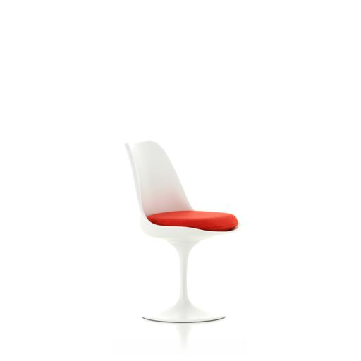

## 2010.5; Tulip Chair, 1956

Designer: Eero Saarinen  
Maker: Vitra Design Museum  
Material: lacquered polyurethane, aluminum, fabric  
Donor: David & Terrie Irvin

## Noguchi Table in Cherry

## 2011.1; Noguchi Table in Cherry, 1947

Designer: Isamu Noguchi  
Maker: Paris Renfroe Design  
Material: acrylic, cherrywood  
Donor: Eloise Kruger Charitable Trust

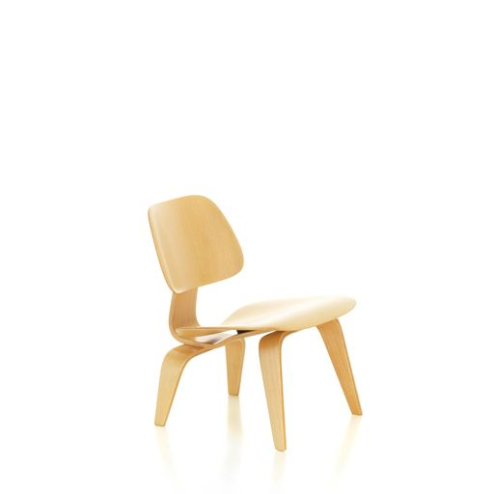

## 2011.3; LCW, 1945

Designer: Charles & Ray Eames   
Maker: Vitra Design Museum  
Material: laminated wood  
Donor: David & Terrie Irvin

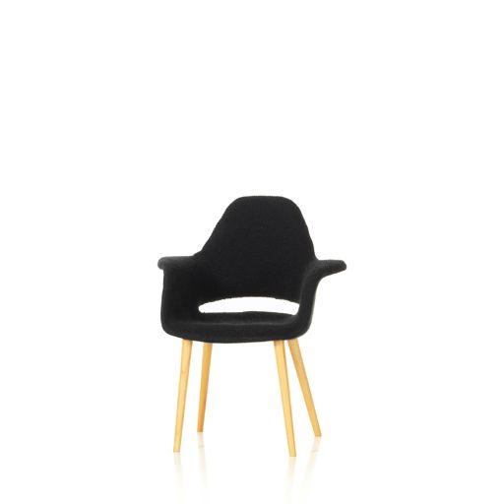

## 2011.4; Organic Armchair, 1940

Designer: Charles Eames, Eero Saarinen  
Maker: Vitra Design Museum  
Material: molded plywood, birch wood, foam rubber, fabric  
Donor: David & Terrie Irvin

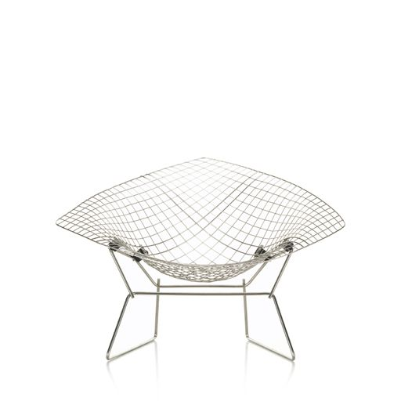

## 2012.1; Diamond Chair, 1952/53

Designer: Harry Bertoia  
Maker: Vitra Design Museum  
Material: steel wire  
Donor: David & Terrie Irvin

## Art 41 Paimio

## 2012.2; Art 41 Paimio, 1930/31

Designer: Alvar Aalto  
Maker: Vitra Design Museum  
Material: plywood, lacquer  
Donor: David & Terrie Irvin

## Robie House2012.3; Robie House 1, 1908

Designer: Frank Llyod Wright  
Maker: Vitra Design Museum  
Material: cherrywood, polyurethane foam, fabric  
Donor: David & Terrie Irvin

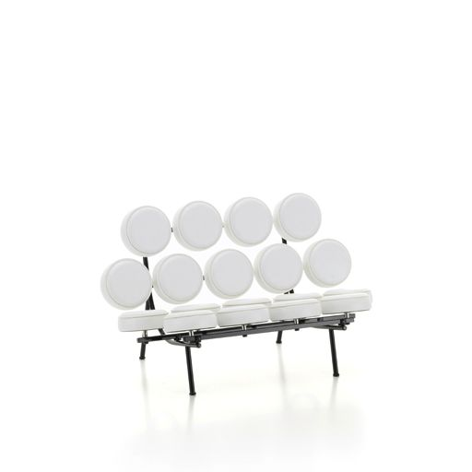

## 2012.4; Marshmallow Sofa, 1956

Designer: George Nelson  
 Maker: Vitra Design Museum  
 Material: varnished steel tubing, aluminum, leather  
 Donor: Al Stone Fund

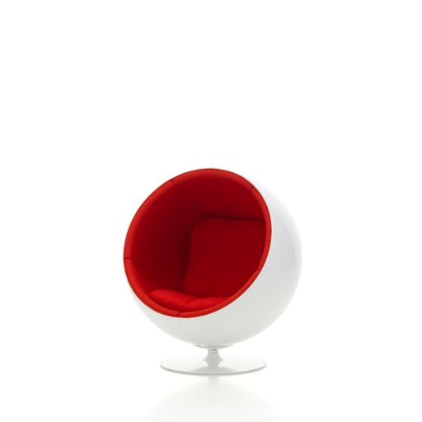

## 2012.5; Ball Chair, 1965

Designer: Eero Aarnio  
Maker: Vitra Design Museum  
Material: fiberglass, aluminum, fabric  
Donor: Al Stone Fund

## RAR 1950

## 2012.6; RAR, 1950

Designer: Charles & Ray Eames  
Maker: Vitra Design Museum  
Material: plastic, steel wire Eiffel tower base, wood  
Donor: Al Stone Fund

## DKR

## 2012.7; DKR, 1951

Designer: Charles & Ray Eames  
Maker: Vitra Design Museum  
Material: chromium-plated steel wire  
Donor: Al Stone Fund

## A group of colorful chairs

## 2012.8 a-e; Panton Chairs, 1959/60

Designer: Verner Panton  
Maker: Vitra Design Museum  
Material: plastic  
Donor: Al Stone Fund

## Antony2012.9; Antony, 1950

Designer: Jean Prouvé  
Maker: Vitra Design Museum  
Material: bent plywood, lacquered steel tubing, steel sheet  
Donor: Al Stone Fund

## A wooden stool. two pieces connected together, with a curved top

## 2012.10; Butterfly, 1954

Designer: Sori Yanagi  
Maker: Vitra Design Museum  
Material: bent plywood, brass  
Donor: Al Stone Fund

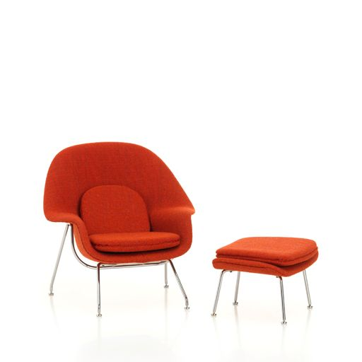

## 2012.11 a, b; Womb Chair & Ottoman

Designer: Eero Saarinen  
Maker: Vitra Design Museum  
Material: glass fiber reinforced plastic shell, fabric, chrome  
Donor: Al Stone Fund

## DSW

## 2012.12; DSW, 1950

Designer: Charles & Ray Eames  
Maker: Vitra Design Museum  
Material: plastic shell, wood, wire  
Donor: Al Stone Fund

## A black and white chair with a curved triangle shape2012.13; Coconut Chair, 1955

Designer: George Nelson  
Maker: Vitra Design Museum  
Material: steel, glass-fiber reinforced plastic, leather  
Donor: Al Stone Fund

## Aluminum Chair

## 2012.14; Aluminum Chair, 1958

Designer: Charles & Ray Eames  
Maker: Vitra Design Museum  
Material: polished cast aluminum, leather  
Donor: Al Stone Fund

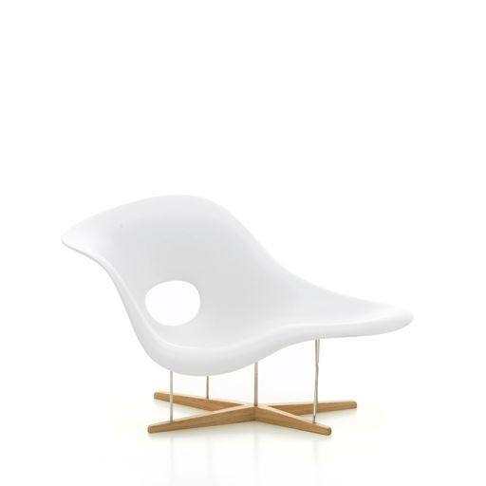

## 2012.15; La Chaise, 1948

Designer: Charles & Ray Eames  
Maker: Vitra Design Museum  
Material: fiberglass, iron rods, wood  
Donor: Al Stone Fund

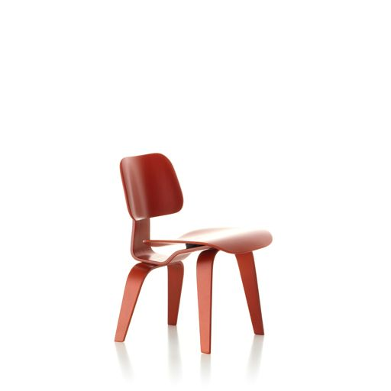

## 2014.1; DCW, 1945

Designer: Charles & Ray Eames  
Maker: Vitra Design Museum  
Material: laminated wood, stain  
Donor: David & Terrie Irvin

## LCM2014.2; LCM, 1945/46

Designer: Charles & Ray Eames  
Maker: Vitra Design Museum  
Material: laminated wood, nickel plated tubular steel  
Donor: David & Terrie Irvin

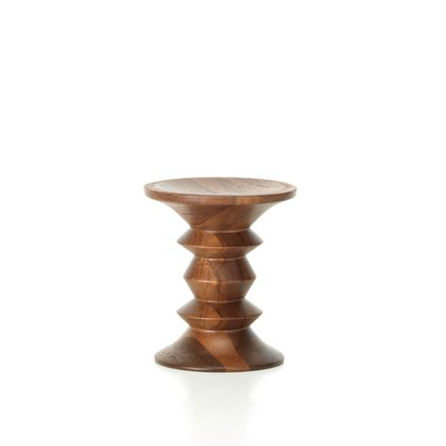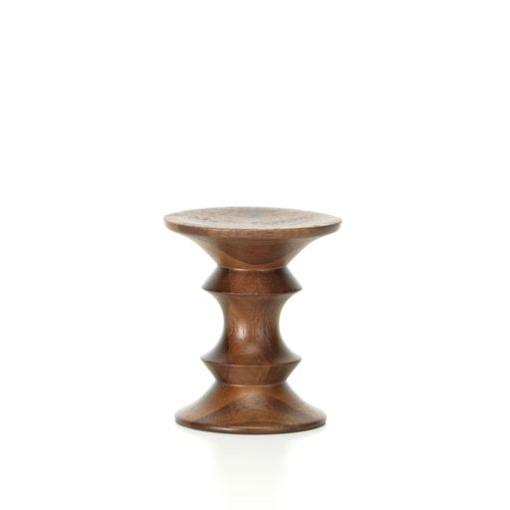

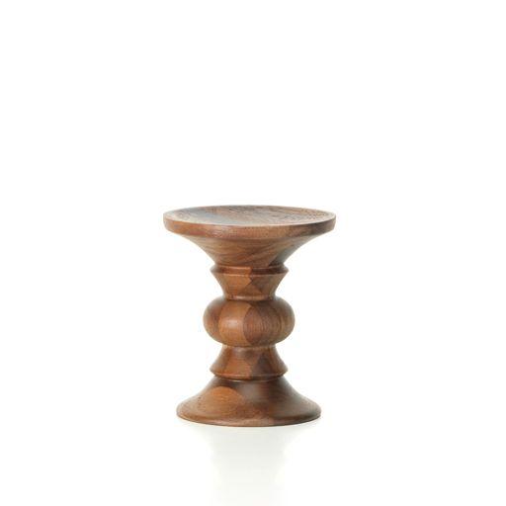

## 2014.3 a, b, c; Stools, 1960

Designer: Charles & Ray Eames  
Maker: Vitra Design Museum  
Material: solid walnut, varnish  
Donor: David & Terrie Irvin

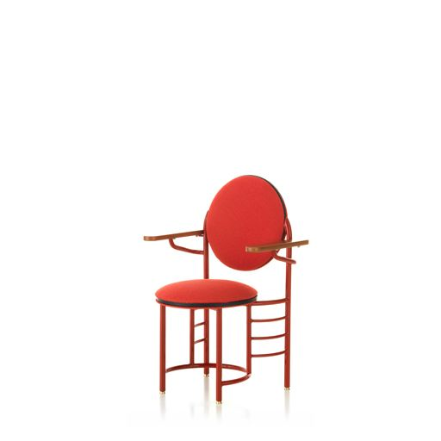

## 2015.1; Johnson Wax Chair, 1939

Designer: Frank Llyod Wright  
Maker: Vitra Design Museum  
Material: metal, cloth upholstery, cherry wood  
Donor: David & Terrie Irvin

## MR 20

## 2015.2; MR 20, 1927

Designer: Ludwig Mies van der Rohe  
Maker: Vitra Design Museum  
Material: nickel-plated tubular steel, natural leather  
Donor: David & Terrie Irvin

## A blue chair with wooden legs2016.1; Taliesin West Amrchair, 1946

Designer: Frank Llyod Wright  
Maker: Vitra Design Museum  
Material: birch plywood, maple, textile, copper sheet  
Donor: David & Terrie Irvin

## B3 Wassily

## 2018.1; B3 Wassily, 1925

Designer: Marcel Breuer  
Maker: Vitra Design Museum  
Material: nickel-plated tubular steel, leather  
Donor: David & Terrie Irvin

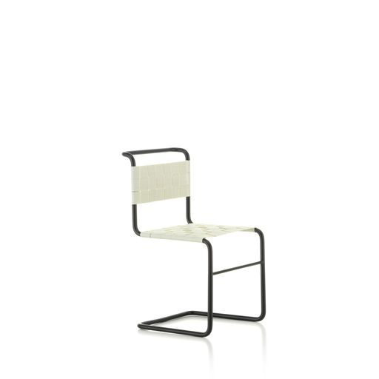

## 2018.2; Stuhl W 1, 1926

Designer: Mart Stam  
Maker: Vitra Design Museum  
Material: lacquered tubular steel, fabric bands  
Donor: David & Terrie Irvin

## A silver, riveted lounge chair2025.3; Lockheed Lounge, 1986

Designer: Marc Newsom  
Maker: Vitra Design Museum  
Material: fiberglass, rubber, riveted sheet aluminum  
Donor: David & Terrie Irvin

## A chair and ottoman made out of corrugated cardboard

## 2025.4; Little Beaver, 1986

Designer: Frank Gehry  
Maker: Vitra Design Museum  
Material: corrugated carboard  
Donor: David & Terrie Irvin

## A wooden chair shaped like a half barrel with slats and a red cushion

## Uncatalogued; Barrel Chair, 1904

Designer: Frank Llyod Wright  
Maker: Vitra Design Museum  
Material: cherrywood, velour cover, plastic glides